Exercise 1: Mocking and Stubbing
Scenario:
You need to test a service that depends on an external API. Use Mockito to mock the external API and stub its methods.

Steps:
- Create a mock object for the external API.
- Stub the methods to return predefined values.
- Write a test case that uses the mock object.

Solution Code:

import static org.mockito.Mockito.*;
import org.junit.jupiter.api.Test;
import org.mockito.Mockito;
public class MyServiceTest {
@Test
public void testExternalApi() {
ExternalApi mockApi = Mockito.mock(
ExternalApi.class
);
when(mockApi.getData()).thenReturn("Mock Data");
MyService service = new MyService(mockApi);
String result = service.fetchData();
assertEquals("Mock Data", result);
}
}

Exercise 2: Verifying Interactions
Scenario:
You need to ensure that a method is called with specific arguments.

Steps:
- Create a mock object.
- Call the method with specific arguments.
- Verify the interaction.

Solution Code:
import static org.mockito.Mockito.*;
import org.junit.jupiter.api.Test;
import org.mockito.Mockito;
public class MyServiceTest {
@Test
public void testVerifyInteraction() {
ExternalApi mockApi = Mockito.mock(ExternalApi.class);
MyService service = new MyService(mockApi);
service.fetchData();
verify(mockApi).getData();
}
}
SOLUTION CHECKLIST (COMBINED EX_1 & EX_2)

- Interface/class ExternalApi created with a method getData()
- Class MyService implemented with:
  - Constructor that accepts an ExternalApi instance
  - Method fetchData() that calls externalApi.getData()
- Test class MyServiceTest created under src/test/java/com/cognizant

🧪 Exercise 1: Mocking and Stubbing

- In testExternalApi():
  - Created mock object using Mockito.mock(ExternalApi.class)
  - Stubbed getData() to return "Mock Data" using when(...).thenReturn(...)
  - Created a MyService instance using the mock Called fetchData() and asserted result with:
assertEquals("Mock Data", result);

🧪 Exercise 2: Verifying Interactions

- In testVerifyInteraction():
  - Created mock object of ExternalApi
  - Passed it to MyService and called fetchData()
  - Verified interaction using:
    - verify(mockApi).getData();

- Required imports added:

import static org.mockito.Mockito.*;
import static org.junit.Assert.assertEquals;
import org.junit.Test;

- Tests executed using mvn test and passed successfully

OUTPUT

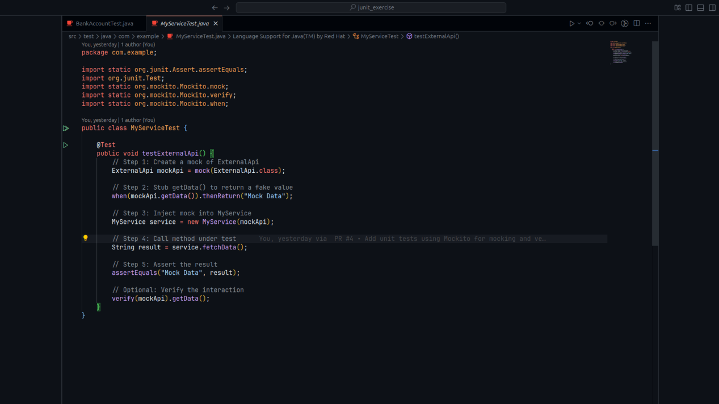

RUNNING TEST

